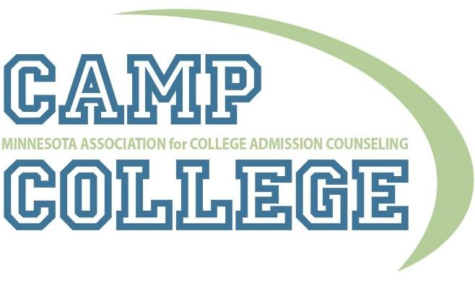

Institutional Host Application for Summer 2019

What is Camp College?
Camp College is a pre-college experience where underrepresented and first-generation Minnesota high school students have the opportunity to be exposed to a college campus while learning valuable information on the college search process from higher education mentors.

While they experience life at a college or university, Camp College participants learn about all aspects of this process, including navigating college options, applying for college, taking the SAT or ACT, exploring financial aid options and much more. The goal of Camp College is to have students leave the program with the knowledge and confidence necessary to successfully transition from high school to college, and to learn while HAVING FUN!

MACAC’s Camp College is made possible through the generous donations of its host
institution along with other college and university sponsors. The program also receives
support from both MACAC and additional sponsors and donations.

Qualifications host institutions must meet:
- The institution must agree to hosting Camp College during the summer of 2019.
- The institution must be able to offer a variety of spaces where the event will be hosted:
  - There must be residence hall space for a minimum of 50 people (30 students, 10 mentors, and 10 additional staff), a common gathering space for all participants, and various classrooms to accommodate breakout sessions.
  - Certain spaces must be available for four consecutive days—for the three-day event and one day prior for set-up and mentor training.
- The institution must firmly commit to cover some of the cost of meals and housing for all program participants, including students, mentors, and programming staff. This expense will vary by institution. MACAC has funds to support some of these costs, please work with the planning chairs to discuss what may work for you.
- The institution must assign a site coordinator who will be responsible for working with MACAC in the planning and implementation of Camp College on the chosen campus.

Institutional Host Application for Summer 2019

All bids for hosting will be reviewed by a committee of individuals from MACAC. The deadline for submissions is July 15, 2018.

Name: _________________________________________________________________

Email Address: ___________________________________________________________

Institution Name and Location: ______________________________________________

Please indicate your hosting preferences:
_____ It would be ideal to host this program during the week.
_____ It would be ideal to host this program during the weekend.

If my institution is not selected to host for 2019, I would like it to be considered as an alternate option, or for future years: Yes _____ No_______

Please indicate dates in summer 2019 that your institution would be willing to host MACAC’s Camp College (the ideal dates would be during July 2019):

In the space below, please answer the following questions in 500 words or less:
- Why would your institution be an appropriate host for MACAC’s Camp College?
- How has your institution been demonstrating its commitment to access to education for all students?

Question Response:

Institutional Host Acceptance for Summer 2019

ELECTRONIC FINANCIAL COMMITMENT:
I, __________________________ (name),____________________(title) on behalf of
_______________________________ (institution name), confirm my institution’s
commitment to host MACAC’s Camp College and cover the cost of housing and
meals for all program participants. Additionally, I certify that I have read the host
qualifications as listed in this application and my institution meets all
specifications. I acknowledge that I am authorized to sign on behalf of my office
and institution.
Electronic signature: ________________________________________
Date: _______________

